

**A PROJECT REPORT ON**

**LULC CLASSIFICATION OF WULAR CATCHMENTS**

**BY:**

**BAPI LASKAR (2023UCS0087)**

**RITIK CHHITROLIA (2023UCS0107)**

**UNDER MENTORSHIP OF:**

**DR. CHEMBOLU VINAY**

### **Abstract**

This project presents a comprehensive spatiotemporal analysis of Land Use Land Cover (LULC) changes in the direct catchment of Wular Lake, situated in the ecologically sensitive region of Jammu & Kashmir, India. Leveraging the cloud-based capabilities of Google Earth Engine (GEE), a time series of Landsat satellite imagery from 1991 to 2020 was processed using supervised classification techniques. The study identified and monitored six key land cover categories— water, snow, barren, built-up, forest, and agriculture—to better understand landscape dynamics over nearly three decades.

We performed the analysis at both the catchment and sub-catchment levels to capture spatial heterogeneity in land cover transitions. The methodology involved robust preprocessing, training region delineation, classification, and post-classification change detection. Results reveal a significant reduction in forested areas and increased built-up zones, especially in lower catchments closer to human settlements. Agricultural expansion and variability in snow and barren lands further indicate climatic and anthropogenic pressures.

These transformations have direct implications for the hydrological and ecological health of Wular Lake, contributing to increased sedimentation, water quality degradation, and habitat fragmentation. The findings underscore the need for integrated catchment management strategies, long-term monitoring, and policy interventions for sustainable land use. This study demonstrates the effectiveness of GEE for large-scale LULC assessment and contributes to understanding the environmental stressors impacting one of India's most critical freshwater ecosystems.

### **1. Introduction**

Wular Lake, located in Jammu and Kashmir, is one of the largest freshwater lakes in South Asia. It plays a crucial role in the hydrology and ecology of the Kashmir Valley. However, over the past few decades, increasing anthropogenic pressure, urbanization, and land use changes in the surrounding catchment have led to alarming ecological impacts on the lake.

This project aims to examine the LULC dynamics within the **direct catchment** of Wular Lake. The goal is to monitor how different land classes have changed over time, how these changes vary in sub-catchments, and how they could be imp

acting the lake’s health

### **2. Study Area**

Wular Lake, located in the Bandipora district of Jammu and Kashmir, is one of the largest freshwater lakes in South Asia and a crucial component of the Jhelum River Basin. Positioned approximately 34 km northwest of Srinagar at an elevation of 1,530 meters above mean sea level, the lake lies between latitudes 34°16′N to 34°21′N and longitudes 74°33′E to 74°44′E. The lake’s shape is roughly elliptical, with a maximum length of 16 kilometers and a breadth of 7.6 kilometers. Seasonal variations significantly affect the lake's size, with its area fluctuating between 30 and 189 square kilometers due to changes in water inflow and monsoonal flooding.

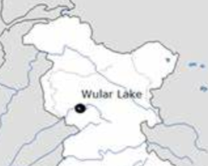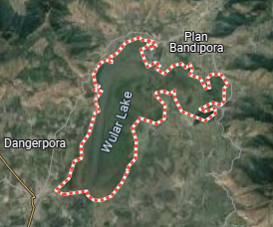

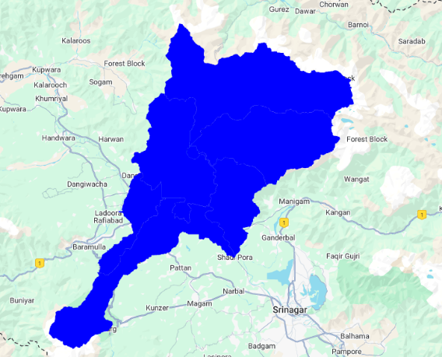

The lake is primarily fed by the Jhelum River and several tributaries, including the Erin and Madhumati streams, which originate from the high mountainous ranges to the north and northeast. The eastern and southern margins of the lake consist of low-lying, flood-prone zones such as Sonawari, which were historically inundated but have been reclaimed through embankments and brought under paddy cultivation and plantation of willow and poplar trees. On the western side, near the Sopore-Watlab region, similar agricultural transformation has occurred.

Wular Lake plays a vital role in the hydrological regulation of the Kashmir Valley. It functions as a natural flood basin, buffering peak discharges and maintaining base flows in the downstream sections of the Jhelum River. In addition to its hydrological importance, the lake supports a wide range of biodiversity, serving as a critical habitat for migratory waterbirds along the Central Asian Flyway. The aquatic ecosystem harbours a diverse range Fish species, aquatic vegetation, and the large-scale collection of **water chestnuts** and other wetland products support the livelihoods of local communities These and other wetland products significantly that contribute to the livelihoods of local communities.

The direct catchment of Wular Lake comprises six major sub-watersheds spread over an area of approximately **1,454 square kilometers**. These catchments drain directly into the lake and are characterized by diverse land cover types, including coniferous forests, alpine pastures, orchards, snow-covered terrain, barren lands, and rapidly expanding built-up areas. The surrounding landscape has undergone considerable degradation due to deforestation, overgrazing, and unregulated development, contributing to increased sedimentation and shrinkage of the lake over time.

Wular is also home to 31 villages, mostly falling within the Bandipora and Baramulla districts, with a population of over 10,000 households. Many of these communities are impoverished and heavily rely on the lake and its resources for fishing, agriculture, and seasonal employment. In recognition of its ecological and socio-economic value, Wular Lake was designated as a **Ramsar Wetland of International Importance** in 1990.

### **03. Dataset Used**

* **Satellite Imagery**: Landsat datasets (from GEE) for the years 1991, 1994, 1996, 2000, 2003, 2005, 2008, 2010, 2013, 2015, 2017, 2020.

Landsat 5, Landsat 7 and Landsat 8 was used.

* **Classification Method**: Supervised classification.
* **LULC Classes**:
  + Water
  + Snow
  + Barren
  + Built-up
  + Forest
  + Agriculture
* **Platform Used**: Google Earth Engine (GEE).
* **Data Format**: Output areas were extracted and stored in tabular format using Excel for further processing.

**4. Methodology**:

In this study, we used **Google Earth Engine (GEE)** to classify **Land Use and Land Cover (LULC)** for the **Wular Lake catchment area** using **Landsat 5, 7, and 8** satellite imagery. The focus was on spring-season images (March -April), with the classification carried out for multiple years to observe changes over time.

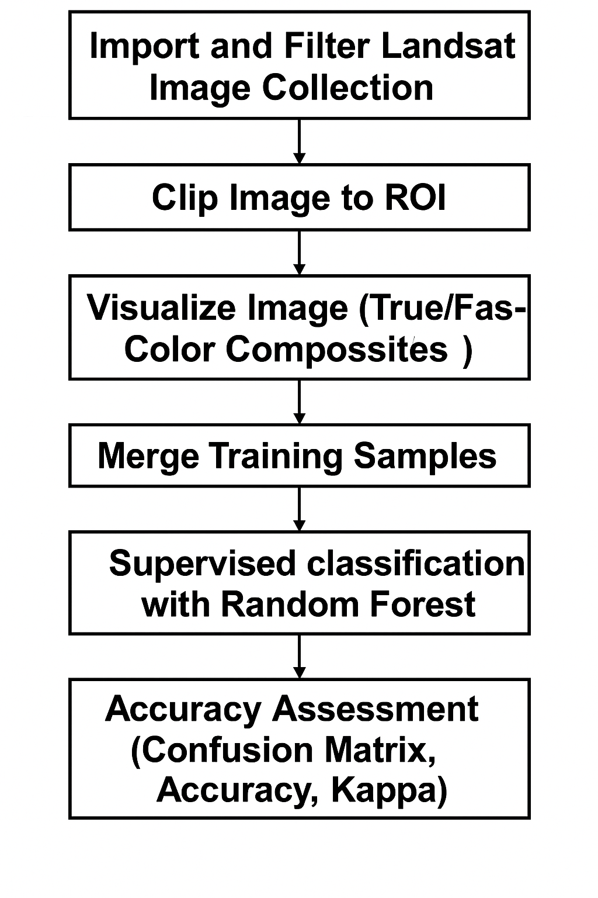

### **4.1 Image Collection and Preprocessing:**

We began by filtering Landsat imagery by **date range** and our **Region of Interest (ROI)**—the Wular catchment area. To ensure accuracy, we selected **cloud-free images** during the spring season and applied **image clipping** to match the study area boundary. These images were then visualized using different **band combinations**, such as **true** and **false color composites**, to better understand and interpret landscape features.

**4.2 Training Data Collection:**

To classify the land cover types, we manually digitized **training samples** for different land cover classes such as:

* **Water**
* **Built-up area**
* **Forest**
* **Agriculture**
* **Snow/Glacier**
* **Barren land**

These labelled points were created using visual interpretation of satellite images. We grouped similar color images into a specific class. This way, classification is done based on different pixel colors. This was done with the help of true and false color composite.

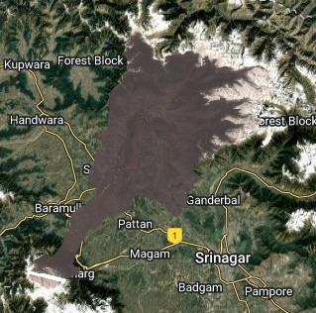Example of a True composites: Example of a False composites:

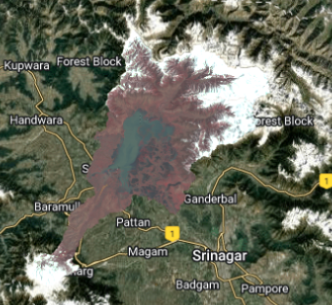

#### **4.3 Supervised Classification using Random Forest:**

We applied the **Random Forest classifier**, a robust and widely used **supervised machine learning algorithm**, to classify the LULC based on the spectral characteristics of the training data. The algorithm was trained using the selected features and used to predict land cover classes across the entire image.

#### **4.4 Visualization and Export:**

The classified output was visualized using a **custom color palette** to clearly distinguish each land cover class. The final classified map was then **exported to Google Drive** for further analysis and documentation.

#### **4.5 Accuracy Assessment:**

To evaluate the reliability of the classification, we generated a **confusion matrix** using the testing dataset. This matrix helped us by calculating the accuracy of each image classification. These provided insight into the performance of the model and its ability to distinguish between land cover types accurately.

#### **4.6 Area Calculation:**

Finally, we used the pixelArea() function in GEE to calculate the **spatial extent of each land cover class**, which allowed us to quantify land use changes and understand the distribution of different landscape features across the catchment. This data is downloaded and further analysed in Excel.

**5. Results:**

The land cover data from 1991 to 2020 shows significant changes in the Wular Lake region. The built-up area increased consistently from **29.45 km²** in 1991 to **127.99 km²** in 2020, indicating rapid urban growth. Agricultural land also expanded, from **307.84 km²** to **388.65 km²**, with a peak of **514.93 km²** in 2010.

The increase suggests conversion of other land types, particularly barren and possibly water areas, into farmland.

Water bodies declined steadily from **173.05 km²** in 1991 to **114.99 km²** in 2020, reflecting a total loss of about **58 km²**. This decline is likely due to lake shrinkage, sedimentation, or encroachment. Barren land also decreased significantly from **182.71 km²** to **90.99 km²**, aligning with the increase in agriculture and built-up classes.

Forest cover showed relative stability, fluctuating between **392.27 km²** (2003) and **511.64 km²** (2000), ending at **404.41 km²** in 2020.

This pattern suggests minimal deforestation or successful forest management. The snow-covered area, starting at **354.84 km²** in 1991, slightly decreased to **329.45 km²** in 2020, possibly due to changing climate patterns.

Classification accuracy remained high throughout, ranging from **79% to 94%**, with the most reliable outputs after 2005. Overall, the trends suggest increasing anthropogenic influence, particularly expansion of agriculture and urban areas, accompanied by a reduction in water and barren lands.

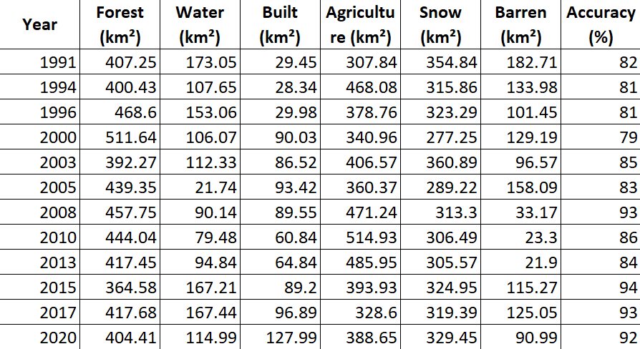

These trends suggest substantial land use transformation, likely driven by human activities such as agricultural expansion and urbanization, along with environmental changes like water body shrinkage.

**Increasing**: Agriculture, Built-up

**Decreasing**: Water, Barren

**Stable/Fluctuating**: Forest, Snow

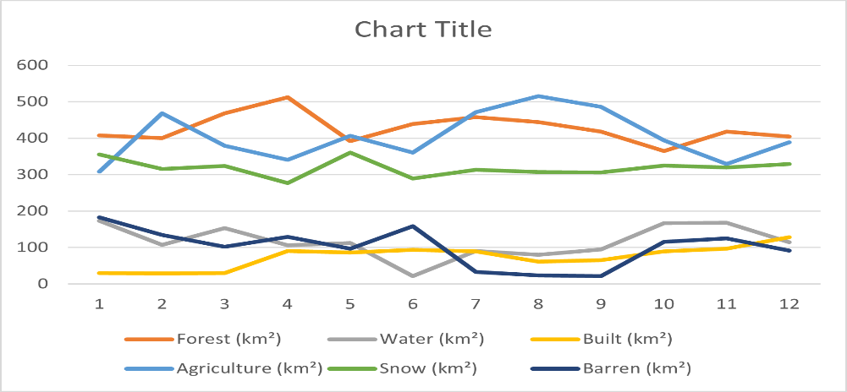

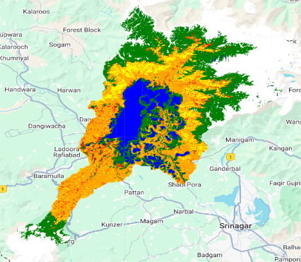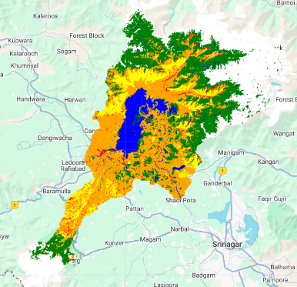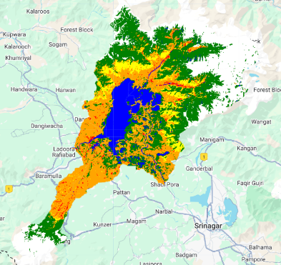

(i) 1991 (ii)1994 (iii)1996

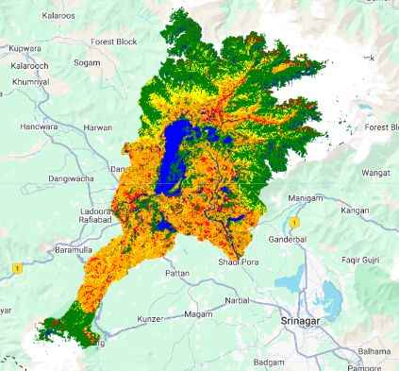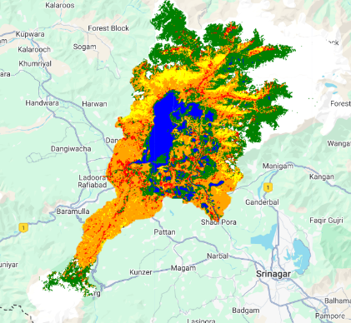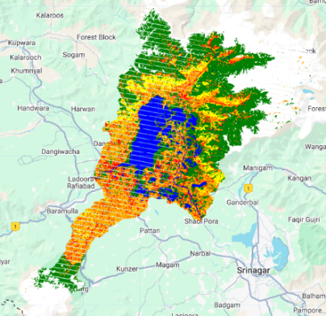

(iv) 2000 (v) 2003 (vi) 2005

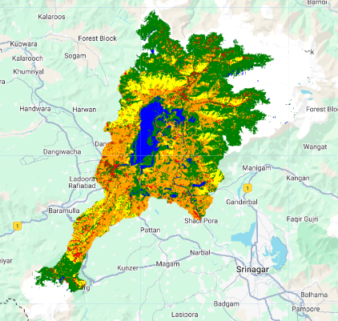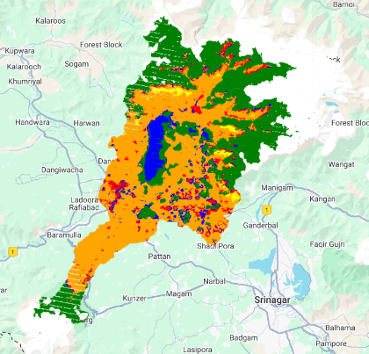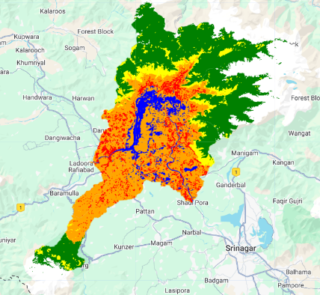

(vii) 2008 (viii) 2010 (ix) 2013

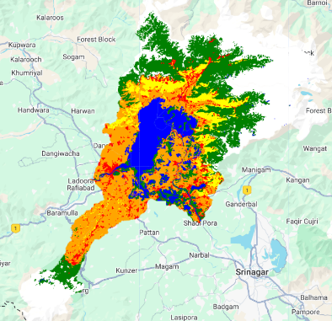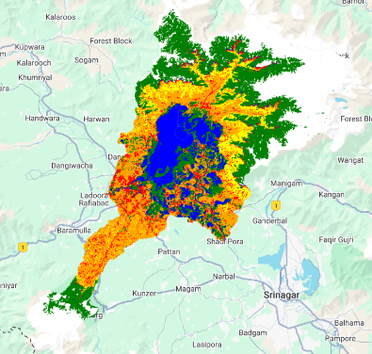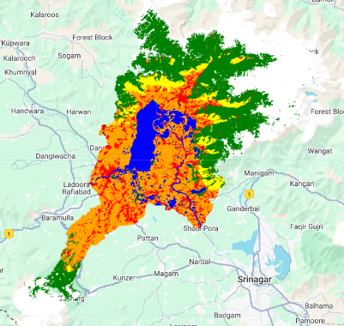

(x) 2015 (xi) 2017 (xii) 2020

We also have classified the region at sub-catchment level. Here is the data given below in m².

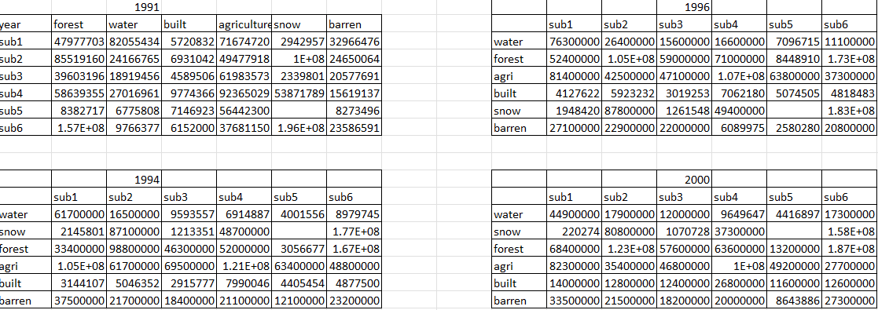

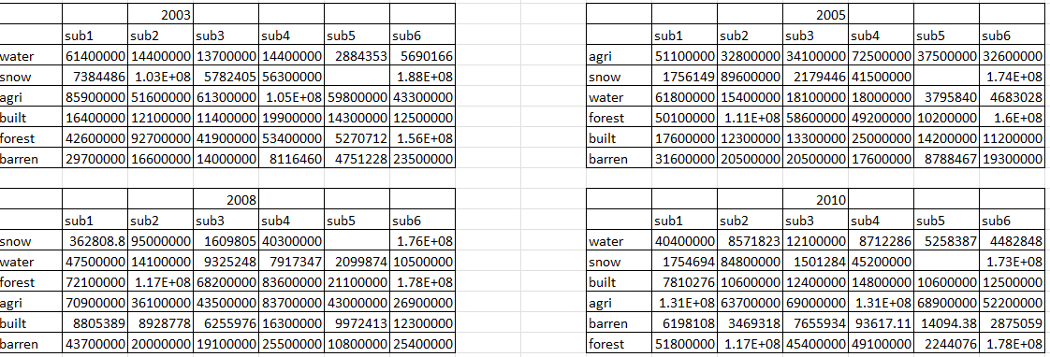

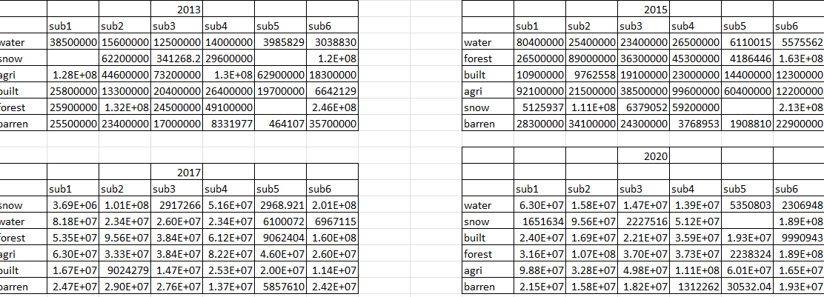

These sub-catchments represent direct contributors to the lake and are defined as follows:

**Sub1 (Wular 1)**

This region encompasses the northern edge of Wular Lake, including adjacent low-lying areas directly connected to the lake. It plays a vital role in the inflow of sediment and nutrients into the lake ecosystem.

**Sub2 (Erin)**

The Erin sub-catchment is a moderately forested area with a hilly landscape and scattered agricultural plots. It supplies freshwater to the lake through the Erin stream.

**Sub3 (Wular 2)**  
Located in the southern surroundings of the lake, this area focuses on water inflow and nearby settlements. It complements Sub1 by influencing the lake's land and water interactions from the opposite side.

**Sub 4 (Gundar)**

Positioned upstream, Gundar contributes to Wular Lake through a small tributary. The region features a mix of natural vegetation, cultivated fields, and limited human habitation.

**Sub 5 (Ningli)**

To the west lies the Ningli sub-catchment, influenced by the Ningli stream. Known for its active agriculture and seasonal flooding, the area experiences dynamic land use changes.

**Sub 6 (Madhumati)**  
Situated in the eastern part of the basin, Madhumati is a key sub-catchment with a combination of forested and agricultural land. It plays a major role in the lake’s hydrology and sediment transport.

The LULC analysis from 1991 to 2020 reveals significant transformations across the sub-catchments. Water bodies showed fluctuations but generally increased, notably in Sub2 from 82.05 km² (1991) to 158.0 km² (2020). Snow-covered areas remained highly variable, peaking in sub6 with over 200 km² in 2017, highlighting climate sensitivity. Forest cover consistently declined, with Sub3 dropping from 168.91 km² in 1991 to just 37.00 km² by 2020, indicating deforestation pressures. Agricultural land expanded until 2010 (e.g., Sub4 reaching 131.0 km²) but declined thereafter, likely due to urban spread. Built-up areas increased sharply in all sub-catchments—sub3 rose from 4.58 km² (1991) to 22.10 km² (2020), marking rapid urbanization. Barren lands fluctuated but showed a slight overall decrease, suggesting conversion to other land uses. Sub1 and sub2 witnessed the most notable growth in water and built-up areas, while sub3 and sub4 showed significant losses in forest and gains in agriculture and urban development. These trends point to increasing anthropogenic pressure, urban expansion, and possible environmental degradation, especially in forest and snow-dominated zones. Understanding these dynamics is critical for planning sustainable land use around the Wular Lake catchment.

**6. Conclusion:**

This study provides a comprehensive analysis of Land Use and Land Cover (LULC) changes across six sub-catchments from 1991 to 2020, revealing significant transformations driven by both natural processes and human activities. The data highlights notable trends in various land cover categories.

Water bodies exhibited fluctuations but generally increased, particularly in Sub2, which expanded from 82.05 km2 in 1991 to 158.0 km2 in 2020. Snow-covered areas remained highly variable, with sub6 peaking over 200 km² in 2017, indicating sensitivity to climatic factors. Forest cover consistently declined, exemplified by sub3's reduction from 168.91 km² to 37.00 km², suggesting deforestation pressures. Agricultural land expanded until 2010, with sub4 reaching 131.0 km², but declined thereafter, possibly due to urban encroachment. Built-up areas increased sharply across all sub-catchments; for instance, sub3 grew from 4.58 km² in 1991 to 22.10 km² in 2020, reflecting rapid urbanization. Barren lands showed a slight overall decrease, indicating potential land conversion.

Sub catchment-specific analyses reveal that sub1 and sub2 experienced significant growth in water and built-up areas, while sub3 and sub4 faced substantial forest losses alongside agricultural and urban development gains. These patterns underscore the escalating anthropogenic pressures and environmental changes within the region.

In conclusion, this study highlights the dynamic nature of land cover changes over nearly three decades, driven by both human activities and climatic factors. Understanding these trends is crucial for informed decision-making aimed at promoting sustainable development and environmental conservation within the sub-catchments.